Java 3 Activity 4 task 3

30003389 – Kyer Potts

Table of Contents

Table of Contents i

Factorial Method 1

Fibonacci Method 2

Recursive Factorial Method trace 3

# Factorial Method

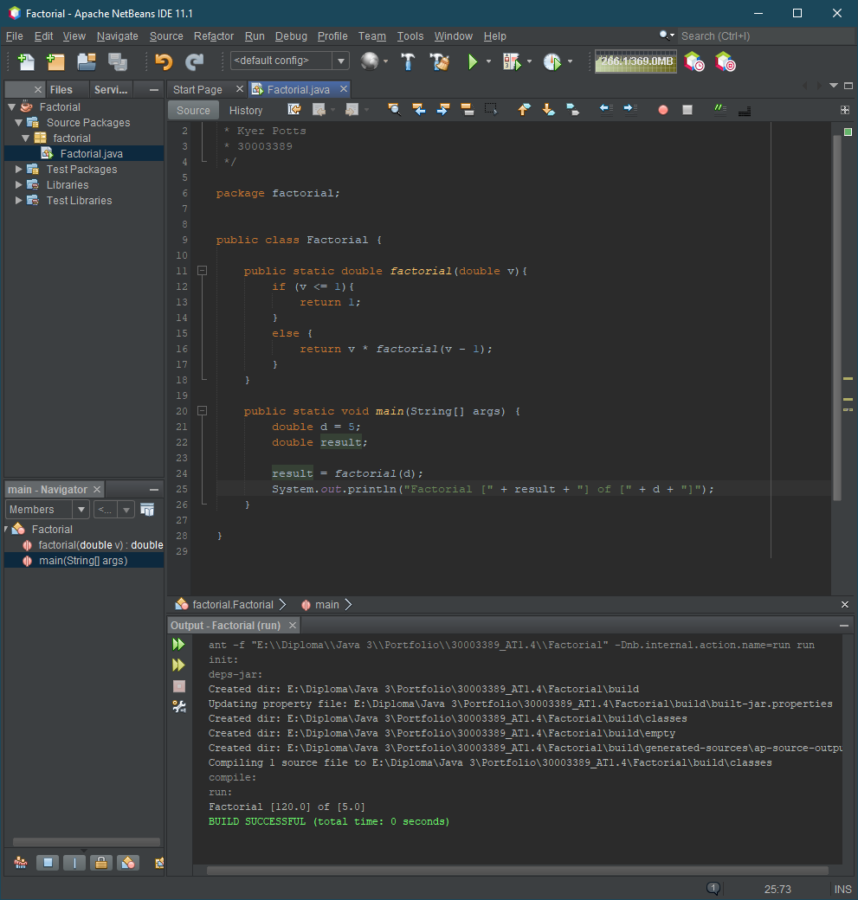

# Fibonacci Method

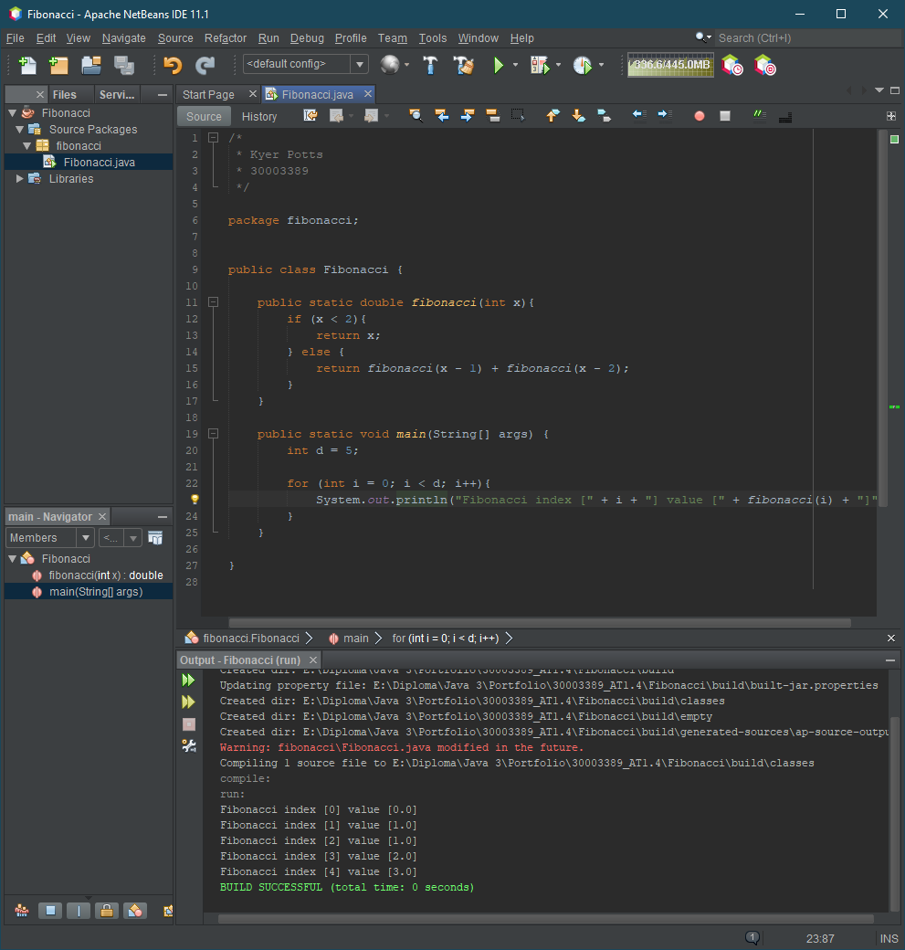

# Recursive Factorial Method trace

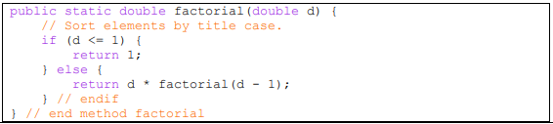

1. The program first determines whether “d” is less than or equal to 1, if so, the program will return a result of 1.
2. If “d” is greater than one, the program returns the value of d multiplied by the method “factorial(d – 1)”. This will begin the run to calculate the factorial of the chosen number, in this case “7”.
3. The first iteration checks if d is greater than 1, it is, so it runs the recursive method which calls a second iteration of the factorial method
4. The second iteration checks if d is greater than 1, it is, so it runs the recursive method which calls a third iteration of the factorial method
5. This continues until the factorial method decrements “d” to 1, at which point the program will return a value of 1 and close all of the factorial method iterations to produce the factorial result.